Chapter 10, Problem 91.

Consider the oscillator in Fig. 10.133,

(a) Determine the oscillation frequency,

(b) Obtain the minimum value of R for which oscillation takes place.
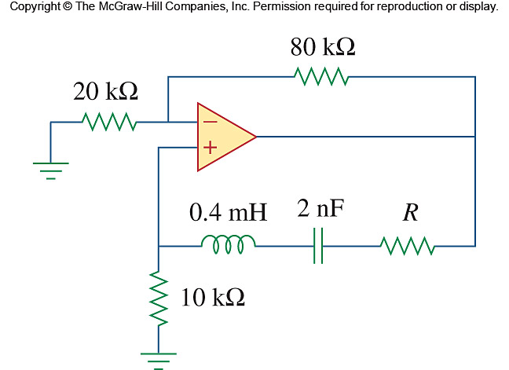

Figure 10.133
For Prob. 10.91.

